  p.38～p.45 |  |  |  |  | Active Study Grade２ 単元別確認テスト |  |  | 実施日 月 日
5 |  | 第4章 |  | 接続詞 |  |  | 氏 |  | 得
5 |  |  | when, if, because, that |  |  |  | 名 |  | 点 | /30

１ 次の英文は、Active Studyで学習した文章の内容をまとめたメモです。 ※文章は裏面に掲載
メモを完成するために、①～③にあてはまる英単語を書きなさい。ただし、□には1文字ずつ入るものとします。

We see many kinds of tomatoes at the (① □□□□□□□□□□□). In the past, people believed tomatoes were (② □□□□□□□□□) and enjoyed looking at them as flowers. Some people tried eating them and found they were (③ □□□□) and tasty.

１ （5点×３）
supermarket
poisonous
safe

２ 意味の通る正しい英文になるように、（ ）内の語句を並べかえなさい。

- ( rainy / go / if / tomorrow / the park / I / it / won’t / is / to / , ).
- ( we / we / when / kinds of / go / a supermarket / see / many / to / tomatoes ).
- ( not / tomatoes / only / also / people / were / that / safe / found / but ) delicious.

２ （5点×３）
If it is rainy tomorrow, I won’t go to the park.
We see many kinds of tomatoes when we go to a supermarket.
People found that tomatoes were not only safe but also

次の英文の日本語訳を書きなさい。 解説 ▶ テキスト P.41

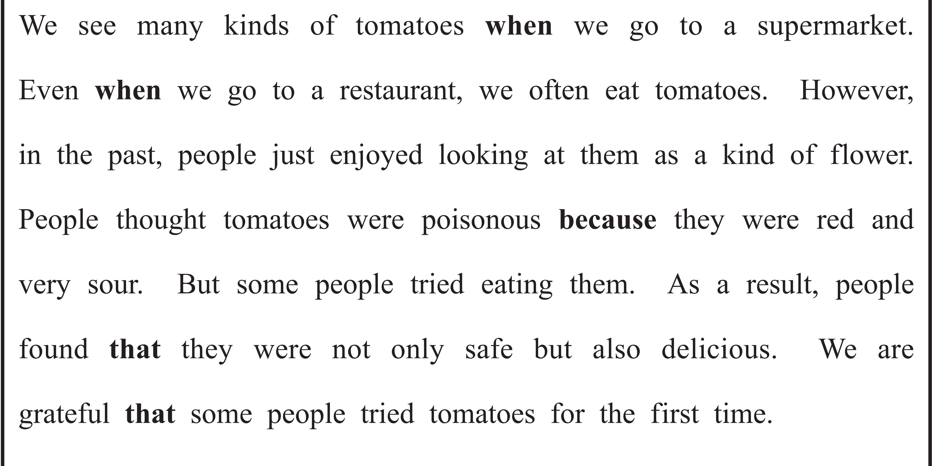
（82語）

