  p.22～p.29 |  |  |  |  | Active Study Grade３ 単元別確認テスト |  |  | 実施日 月 日
3 |  | 第2章 |  | 現在完了 |  |  | 氏 |  | 得
3 |  | １. | 継続用法 |  |  |  | 名 |  | 点 | /30

１ 次の英文は、Active Studyで学習した文章の内容をまとめたメモです。 ※文章は裏面に掲載
メモを完成するために、①～③にあてはまる英単語を書きなさい。ただし、□には1文字ずつ入るものとします。

Jeans have been (① □□□□□□□) since they were created as workwear. The small pocket above the larger front pocket was originally made to (② □□□□) a pocket watch. Though wristwatches became popular, the small pocket has (③ □□□□□□□□) on jeans.

１ （5点×３）
popular
hold
remained

２ 意味の通る正しい英文になるように、（ ）内の語句を並べかえなさい。

- ( London / have / in / you / three / lived / years / for )?
- ( it / since / Wednesday / not / rained / last / has ) .
- ( have / they / since / people / wearing jeans / created / were / loved ) as workwear.

２ （5点×３）
Have you lived in London for three years?
It has not rained since last Wednesday.
People have loved wearing jeans since they were created

次の英文の日本語訳を書きなさい。 解説 ▶ テキスト P.25

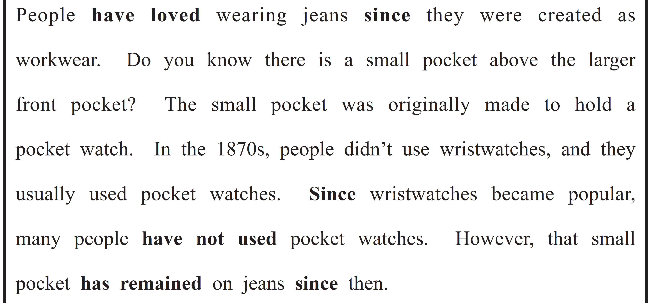

（69語）

