  p.134～p.141 |  |  |  |  | Active Study Grade２ 単元別確認テスト |  |  | 実施日 月 日
17 |  | 第9章 |  | 比較 |  |  | 氏 |  | 得
17 |  | 3. | いろいろな比較表現 |  |  |  | 名 |  | 点 | /30

１ 次の英文は、Active Studyで学習した文章の内容をまとめたメモです。 ※文章は裏面に掲載
メモを完成するために、①～③にあてはまる英単語を書きなさい。ただし、□には1文字ずつ入るものとします。

The writer likes rice (① □□□□□□) than bread for breakfast. But now many young people in Japan eat bread more often. Also, many of them want to (② □□□□) in big cities and don't make rice. The writer thinks rice is important for Japanese (③ □□□□□□), so we should protect it.

１ （5点×３）
better
work
culture

２ 意味の通る正しい英文になるように、（ ）内の語句を並べかえなさい。

- ( you / better / breakfast / like / which / to eat / rice or bread / do / for / , )?
- ( often / Japanese / eat / than / people / bread / young / more ) rice now.
- I think rice is ( culture / most / for / one / important / our / the / of / things ).

２ （5点×３）
Which do you like to eat better for breakfast, rice or bread?
Young Japanese people eat bread more often than
one of the most important things for our culture.

次の英文の日本語訳を書きなさい。 解説 ▶ テキスト P.137

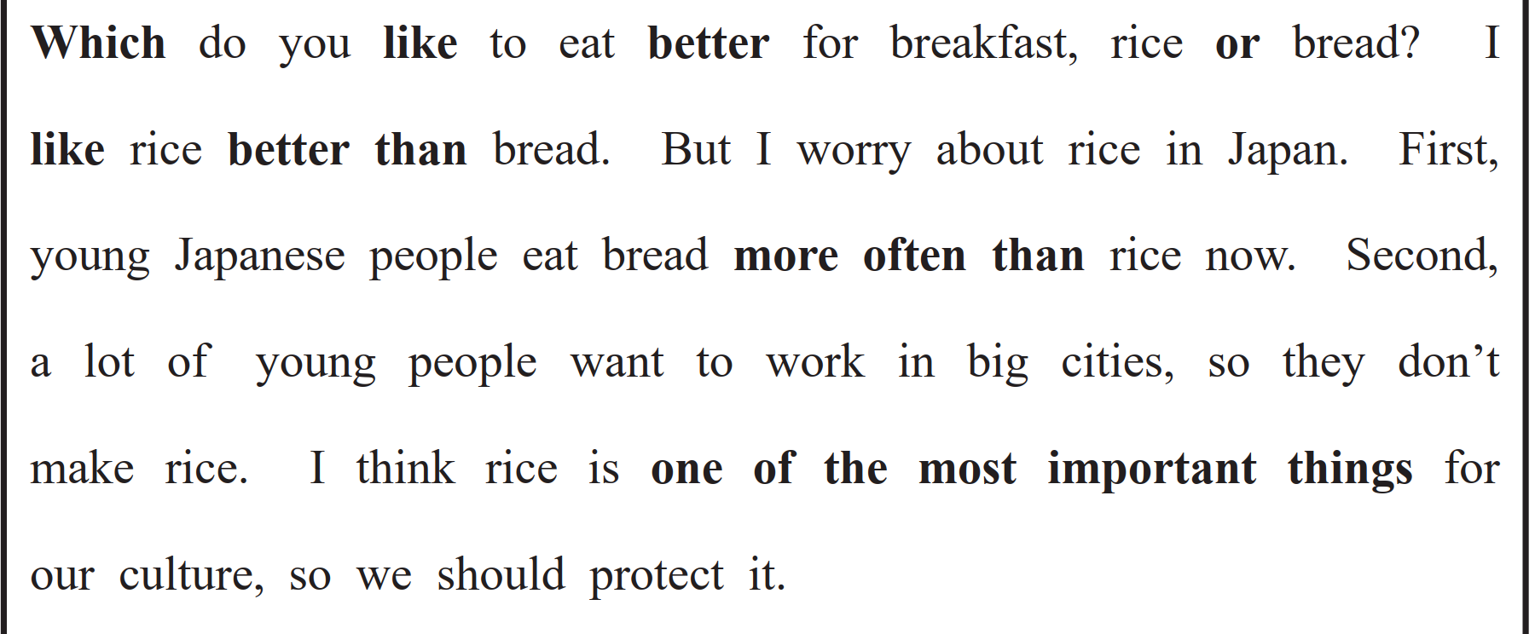
（71語）

