  p.174～p.181 |  |  |  |  | Active Study Grade３ 単元別確認テスト |  |  | 実施日 月 日
22 |  | 第8章 |  | 仮定法 |  |  | 氏 |  | 得
22 |  |  | If ～、 I wish ～ |  |  |  | 名 |  | 点 | /30

１ 次の英文は、Active Studyで学習した文章の内容をまとめたメモです。 ※文章は裏面に掲載
メモを完成するために、①～③にあてはまる英単語を書きなさい。ただし、□には1文字ずつ入るものとします。
Sana doesn't like (① □□□□□) bitten by mosquitoes, although she enjoys summer. She once wished that there were no mosquitoes, but later she found out an important fact. (② □□□□□□□) mosquitoes, making chocolate would not be possible, because they are the (③ □□□□) insects that can pollinate the small cacao flowers.

１ （5点×３）
being
Without
only

２ 意味の通る正しい英文になるように、（ ）内の語句を並べかえなさい。

- ( I / I / car / a / had / wish ).
- If she ( museum / were / go / with / I / to / would / the / her / free / , ).
- ( in / without / I / world / lived / wish / a / mosquitoes / I ).

２ （5点×３）
I wish I had a car.
were free, I would go to the museum with her.
I wish I lived in a world without mosquitoes.

次の英文の日本語訳を書きなさい。 解説 ▶ テキスト P.177

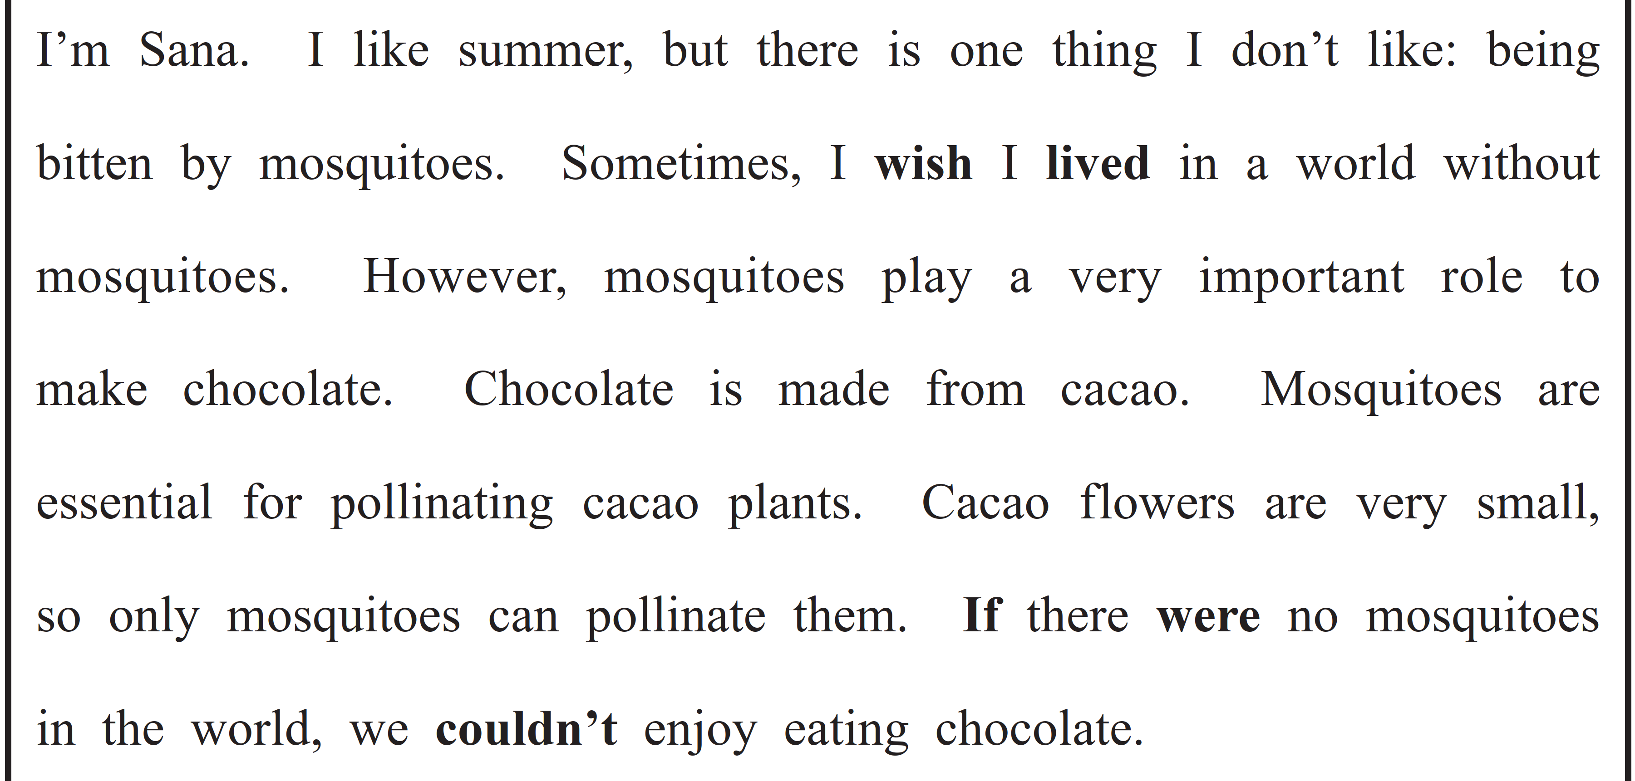

（73語）

